Creating space for urban farming: the role of the planning professional

Paper to be presented on the
7th International AESOP Sustainable Food Planning Conference
Localizing urban food strategies
Farming cities and performing rurality

Torino 8-9 October 2015

Dr. Melika Levelt MSc
Amsterdam University of Applied Sciences/Urban Technology

Key Words
urban farming
governance
participation
planning professional

Abstract

Urban farming projects often involve the (temporarily) redevelopment of urban space by local co-productions of citizens and/or entrepreneurs. To realize their ambitions these coalitions often need support of public (government) resources such as time, money, space and regulation (Green Deal Stadslandbouw, 2013). This paper asks the question to what extent the development of urban farming projects can be understood as an example of planning through direct citizen participation/ participatory governance (e.g. Cornwall, 2004; Roberts, 2004) and what this means for the role of the municipal planning professional or civil servant in making these projects successful.
Literature on the role of the municipal planner or civil servant in urban farming projects mainly concerns the role as enabler of projects given the many difficulties for projects. However, when looked at the development of urban farming as an example of citizen participation/ participatory governance and the transfer of social functions towards society other roles and tasks of planners seem to be important to make urban farming successful. This discussion paper looks to the role of planners and civil servants in some related government domains such as landscape (e.g. Van Dam et al. 2008, 2010, 2011) and neighbourhood development (e.g. Frieling et al., 2014) to complement our understanding of the role of planners in making urban farming projects successful. With this analysis the paper sets the scene for further research into tools for the planning professional or civil servant to support urban farming. In the paper the situation in Amsterdam serves as an example.

1. Introduction: urban farming and bottom-up planning

In 2014 a successful fruit-grower in a Dutch agricultural area, moved to a plot belonging to the municipality of Amsterdam. There he started a new business-concept: ecological growing of fruits for consumers to harvest them on location. First the idea for this business grew in his mind, then he turned to different municipalities to find a location for his business. This wasn’t an easy search but in the end Amsterdam could offer the best possibility. Summer 2015 his ‘harvest-garden’ is open to the public. Bare land has been developed into a garden full of fruits. On top of that, the garden ‘employs’ several disabled and mentally ill people as a social service. As the owner says: he doesn’t expect them to really add to the productivity of the garden but wants to give something back to society with his garden. To realize his ambitions, help of the municipality has been very important. Being a fruit farmer and a chicken farmer and a health care provider and a catering facility in the same time make things complicated regulations- and authorizations-wise. The ambition to also have lodges on the farm where researchers in biology or entomology or other fields could stay for field work, even make things worse. Ideas simply do not fit into existing plans and regulations. Luckily enough the Amsterdam municipality helped him out with many issues popping-up in the process of realizing his ambitions.

In the centre of Amsterdam, close to Amsterdam RAI convention centre, a chicken-farm operates. 200 chickens are kept ecologically. Their faeces are used to fertilize community gardens next to the chicken farm. Before the economic crises in 2006, a chicken farm and community gardens were the latest thing to think about as use for this excellent location. The start of the building of a musical theatre was planned for the end of that year (Gemeente Amsterdam, 2006). But things turned different. Several years later, a movement of citizens, entrepreneurs and civil servants that worked on sustainable energy since 2010 (‘Wij krijgen kippen’(we will get chickens)), looked for a place to keep chickens and produce sustainable energy. Together with the municipal department that develops the office location to the south of Amsterdam (Zuidas) they found this place near the RAI Station. In 2014 the chicken farm Minirondeel started its business and got a license to operate for two years (Minirondeel, 2015). Today, this license has been expanded in anticipation of further development of the area.

The two examples above show the importance of ideas of entrepreneurs and entrepreneurial citizens for the development of urban farming. The examples also show urban farming competes with other uses of space. Lastly, the examples show the importance of government: both needed the help of the municipality to realize their ambitions. Urban farming has gained more and more attention from governments as they are seen as important for the strategic issue of quality of live in the city (green, health, clean air), liveability of neighbourhoods (integration, participation) and often perform social services (e.g. day care for mentally ill and disabled). For example, the municipality of Amsterdam sees urban farming projects as a means to achieve goals with respect to re-integration into society, social goals, educational goals, awareness with respect to food and issues of health and sustainability, and attractiveness of the city (DRO 2014, pp. 11-12).

Given the goals municipalities have with urban farming projects, it is important that projects take place at all. The difficulties urban farming projects find on their way has gained much attention from urban farming researhers. These are for example: finding a way through rules and regulations and getting cooperation of local authorities, for example to find a site for the project (e.g. Green Deal Stadslandbouw i.o., 2013, Miazzo & Minkjan, 2013). Other hurdles mentioned for urban farming projects in particular are (idem) to:
- obtain enough funding (subsidies, gifts);
- obtain enough knowledge (growing techniques; marketing; sales; finance; legal) (especially unlock local available knowledge);
- get the project within regulations;
- find sites for development of urban faring;
- get enough scale;
- diversify to strengthen the project (as most urban farms draw on various sources of revenue (Denckla, 2013);
- be able to make a business case and to be able to achieve funding;
- develop entrepreneurship;
- to find enough volunteers.
Many municipalities and planners seem to be aware of the role they can play in enabling projects and share their experiences with this (for example Miazzo & Minkjan, 2013; URBACT/Sustainable Food in Urban Communities, 2015). However, some more roles for urban planners in making urban farming projects successful seem to be of relevance. We can become aware of these roles when we see how urban farming projects represent two important characteristics of contemporary planning and policy in the Netherlands and Europe.

A first characteristic of contemporary planning visible in urban farming projects is the movement towards citizen and private initiative for the delivery of welfare state services. The last decade – in reaction to the crisis of the welfare state – has shown this turn in planning and policy away from big government. Started in the UK with the Blair government, it has had impact in other countries such as The Netherlands (Raad voor het Openbaar Bestuur, 2012; Van Zuydam et al., 2013). More and more governments expect citizens to take greater responsibilities for wellbeing and social services previously organized by the state, such as care for elderly, sick, and disabled people and for neighbourhood development (Aarts & During, 2006; Hurenkamp et al., 2006) .

The second characteristic of contemporary planning which is relevant to the planning of urban farming is the importance of direct citizen participation that grew in the second part of the 20th century (Roberts 2004). It is part of a turn to local communities as units of planning and action (Chaskin, 2003) to, as Taylor (2007, p. 299) describes “improve public services and to re-engage citizens with the instiutions of government”. Direct citizen participation in planning can take many forms but has one thing in common: it is a form of planning in which citizens participate more directly than through the voice of elected representatives. As such, it can be understood as a form of deliberative governance (e.g. Van de Wijdeven and Hendriks, 2010) which following Metze (2010) ‘promises at least two democratic improvements: first, reflectivity in individuals, conversations and decision making for more informed and supported decision making, and then, more credible decision making’ (Metze, 2010, p. 20). This is part of the shift from government to governance (De Wilde et al., 2014). Thus, planning for urban farming seems to fall in two planning debates: a turn to society for delivering services that have previously been organized by the state, and direct citizen participation in planning.

Taking the situation in Amsterdam as an example, this paper explores what role planners have in urban farming projects looked at it from the viewpoint of the turn to citizen and private initiatives and direct citizen participation in planning. As such it supplements what already is written on the role of planners in (case study) literature on urban farming projects. The paper should be read as a discussion paper. It is a first attempt to bring the issue of urban farming within the discourse of direct citizen participation and citizen initiative. The last section the paper discusses the relevance of bringing urban farming into this discourse and proposes a way forward to use the insights developed in the paper for the development of tools for planners to better enable urban farming.

2. Direct citizen participation in urban farming
Participation democracy can take different forms and levels of activity of citizens. Roberts (2004, p. 320) describes citizen participation as “the process by which members of a society (those not holding office or administrative positions in government) share power with public officials in making substantive decisions and in taking actions related to the community.” She calls it direct participation “when citizens are personally involved and actively engaged” in the decision process and indirect participation “when citizens elect others to represent them in the decision process”. Van Dam et al. (2011, p. 17) give an overview of different classifications of the role of citizens in planning and policy and pay special attention to the classification of Pröpper and Steenbeek (1999) in which six levels of participation of citizens are recognized (see table 1).

Level | Role of citizen
6 | Initiator
5 | Cooperation partner
4 | Co-decision-maker
3 | Advisor
2 | Consulted person
1 | Target group for research or information
0 | No role
Levels of citizen involvement in policy making (source: Van Dam, Salverda and During, 2011, p. 17, translation my own)
This classification adds categories to that of Roberts (2004): direct participation seems to be levels 4-6, levels 1-3 seem not to be part of Roberts’ definition, and indirect participation of Roberts is not in the Pröpper and Steenbeek classification. Cornwall (2004) makes a distinction between invited spaces and popular spaces. At the highest level of participation, citizens take the initiative for developments and, by doing that, create a popular space or arena for action. However, a citizen can also be the initiator of a project in response to an invitation of government. When government is in the lead, Cornwall (2004) speaks of invited space. Besides an invitation to start an initiative in a specific domain or for a specific plot of land, government can also invite citizens to be a cooperation partner, co-decision-maker, or advisor in a policy arena. When citizens only get a role as co-decision-maker, advisor or consulted person, the role of the citizen becomes quite passive and seems to fit better in the description of Frieling et al. (2014, p. 38) of participatory planning in which “residents are involved merely as clients and consumers rather than coproducers of neighborhood liveability”. Frieling et al. (2014, p. 38) mention that in this form, participatory planning does not increase residents’ own initiative. As a target group for research or information the role of the citizen is even more passive.
When we take Amsterdam as an example, urban farming projects seem to fit mostly in levels 5 and 6 of Pröpper and Steenbeek as these are mainly private or citizen initiated projects. Furthermore, projects in Amsterdam take place in invited as well as popular spaces. Map 1 shows professional urban farms in Amsterdam. All of these farms are initiated by entrepreneurs. Most of them have a social function besides the production of food. Map 2 shows volunteer-driven urban vegetable gardens in Amsterdam. Here we see five categories of initiators: citizens; professional non-profit developers of urban vegetable projects; welfare organizations; housing corporations; neighbourhood foundations, and, sometimes, the municipality. For 69 of the 120 projects shown on maps 1 and 2 it was easy to find out through an internet search who initiated the project. It turned out that entrepreneurs, foundations and associations, and citizens are responsible for 56 of these projects. In 9 of these projects housing corporations or a community development organization is involved. Thus, the municipality of Amsterdam, to reach its strategic goals with respect to urban farming (not including school gardens) almost entirely depends on citizen and private initiative. Given the fact that citizen and private initiative is so important for urban farming, it seems to be of relevance to understand the role planners play in citizen initiatives like these.

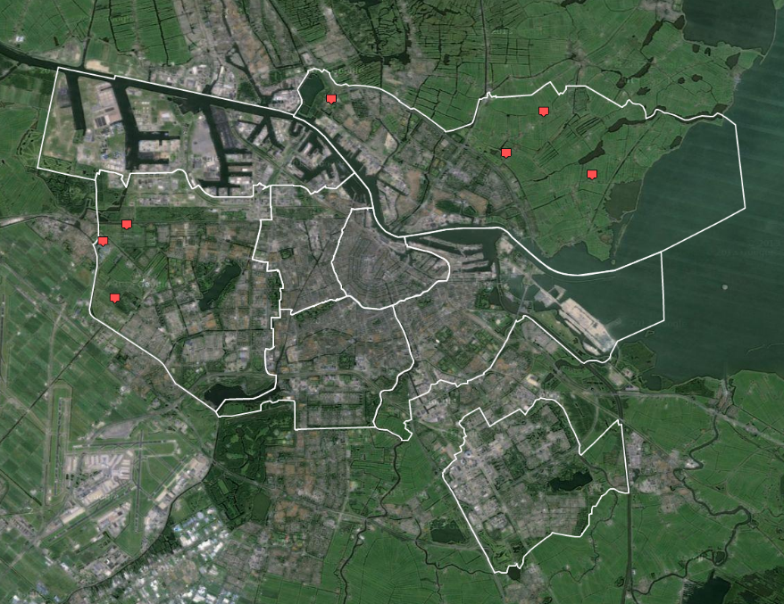
Map 1: Professional urban farms in Amsterdam, source: http://maps.amsterdam.nl/stadslandbouw/, viewed July 17th 2015

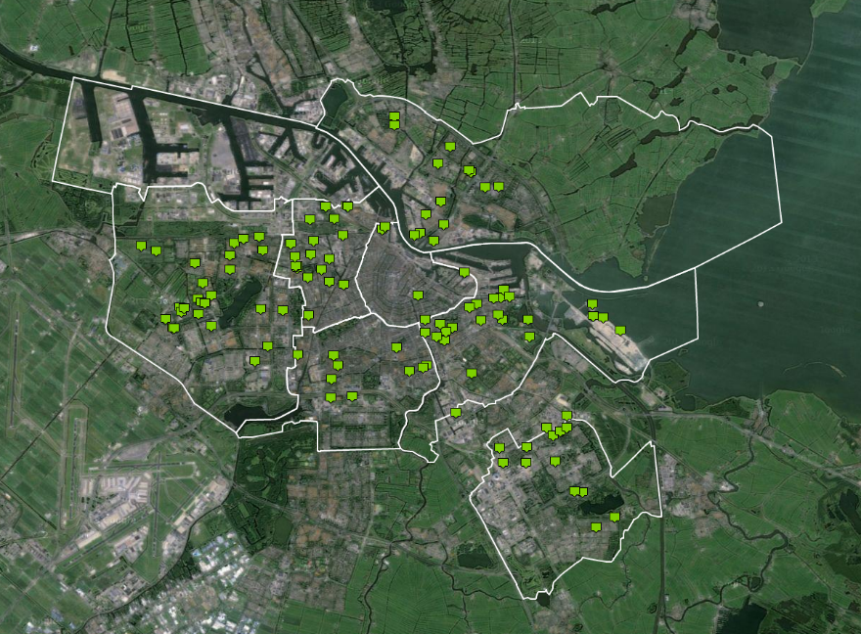
Map 2: Volunteer-driven urban vegetable gardens in Amsterdam (existing and in development, not including school gardens), source: http://maps.amsterdam.nl/stadslandbouw/ , viewed July 17th 2015

3. The roles of planners in direct citizen participation

3.1 Roles of planners
What role then do planners have in direct citizen participation? As mentioned earlier, literature on urban farming has much to say about what urban farming initiatives need to enable them to develop. Proposed actions in this literature to be taken by cities or planners are: help with regulations (remove restrictions and obstacles) (Vermeulen, 2013; Denckla 2013), encouragements to enrich initiatives towards multi-purpose solutions and economy of scope when possible (Vermeulen, 2013), help to generate cross-fertilization between projects (Vermeulen, 2013); make available land for projects, eventually to reduced land prices (Vermeulen, 2013; Denckla, 2013) but also to map which plots are potentially interesting for urban farming (De Graaf, 2013), to help city farms with reduced taxes (Denckla, 2013).

Looked at urban farming as an example of citizen initiatives yet other roles become important. Summarizing literature on direct citizen participation Roberts (2004, pp. 326-327) describes six dilemmas of direct citizen participation which I paraphrase here:
- Dilemma of size: how can numerous groups and individuals participate in direct democracy? How to organize deliberations?
- Dilemma of excluded or oppressed groups: how to include all groups in deliberations and who will speak for future generations?
- Dilemma of risk: how to be able to make decisions about risky affairs by including all people exposed to these risks but at the same time still enable decisions to be made.
- Dilemma of technology or expertise: how to make the voice of citizens as strong as the voices of administrative and technical elites who have much more knowledge?
- Dilemma of time and crisis: how to be able to make quick decisions (as sometimes needed) through direct citizen participation?
- Dilemma of the common good: how to realize thoughtful deliberations that make people think more seriously and fully about public issues?
From these dilemmas I distil two roles for planners or civil servants to make direct citizen participation for urban farming work. They are related to points 1, 2, 4, and 6. Points 3 and 5 do not seem of much relevance for urban farming projects.

3.2 Planners role to engage citizens and include voices: choir director
This role of planners is related to the first two dilemmas. If direct citizen participation is seen as a (new) form of democracy, an important question is whether or not everyone’s voice is heart in the process of planning and development. This issue is often raised in literature on direct citizen participation (e.g. Aarts and During, 2006; Chaskin et al., 2012; Frieling et al., 2014; Gaventa, 2003; Roberts, 2004). It is a matter of technically being able to facilitate deliberations with a large amount of people but also of getting people involved (motivate and empower people to be involved) and keep them involved. The latter two have an important relation to trust. A communicative approach to planning might fail to include all voices when actors do not trust the new planning instrument, for example because they feel it does not serve their interests or that it is not trustworthy because in the end, government will take over the initiative (see Levelt & Metze, 2014, p. 2373 for a discussion of this argument of non-participation at the regional policy level). Also Frieling et al. (2014, p 39) point to the fact that coproduction “requires some form of initial motivation among individuals to invest in the participatory process”.

Planners have an important role to play in making citizen initiatives trustworthy. Planners should be cautious with bringing their own (policy) agenda’s into citizen initiatives. They first and foremost should listen to what initiatives have to offer and what they ask from government (Salverda et al., 2014). This is in line with observations made on engagement of actors at the regional level where the ‘shadow of hierarchy’ can make or break the ability to become credible and successful as a governance network (Levelt & Metze, 2014).

For planners who create an ‘invited space’ for urban farming or other projects, these insights mean they have to be aware of the difficulty to get people involved especially when they have limited room for manoeuvre to offer to the public. Thus, planners have to open the invited space as much as possible to new insights and ideas from citizens and private initiatives. On the other hand, when planning for urban farming starts in popular space, planners role to include voices would be much more to enable fellow citizens to join the initiative as to make it trustworthy to not only the first initiators.

3.3 Planners role to cater for the common good: common good guardian
Care for the common good is very closely related to the previous point. An important question for planners involved in urban farming, much discussed in general in literature on direct citizen participation, is to what extent government stays responsible for the realization of policy goals related to them (Aarts & During, 2006; Van der Steen et al., 2013). Many authors point to the fact that government still is responsible for making explicit and evaluate the public interest of spatial plans (Van der Krabbe et al., 2014; ). Aarts and During (2006) raise the issue of citizen initiative in spatial development which should not result in ‘a series of free states with own rules and regulations’ (p. 43, translation mine). Government should ‘ensure citizen initiatives stay connected to government and the rest of society’ (idem, translation mine). Basic qualities in the spatial domain also include looking after and develop central design challenges (idem, p. 44). This is relevant for urban farming as these projects often demand support from government and thus governments (planners, civil servants) have to evaluate these projects to decide which ones to support: it is a question about evaluation of plans, which “is central to the planning process” (Alexander, 2002, referring to Khakee, 1998). How can planners evaluate plans and make sure they serve the common good?

In line with a communicative approach to planning, “the common good depends on deliberation and not just assurance of political equality or the capture of public opinion” (Roberts 2003, p. 327). The participatory and deliberative models of democracy believe “a common understanding of the good life can and will arise when individuals participate and deliberate in public life” (Häikö, 2007, referring to Barber, 1984 and Dryzec, 2000). Following this line of reasoning, local citizen initiatives should not be used as a way to realize policy goals at a higher level since this presupposes that outcomes of deliberations around these initiatives are pre-set. Citizen initiatives then, should be seen as ways in which in the public domain values are created (Salverda et al., 2014). Planners first and foremost should listen to what initiatives have to offer and what they ask from government (Salverda et al., 2014). As Durose (cited in Verhoeven en Oude Vrielink, 2012, p. 63) states, planners have a role to play in enabling citizens with their ‘thoughtful deliberations’: “Citizen initiatives need support to increase their democratic potential. This is possible when civil servants and social welfare professionals have a focus on citizens. [..and when they] show how to enter into debate with fellow citizens” and to “help citizens to connect to each other […] to harmonise different priorities of citizens and prevent as much as possible unequal relations between citizens with participation”. Thus, one could say, for urban farming projects, whether or not initiated in invited or popular space, planners should play a role as facilitator of thoughtful deliberations between citizens to make sure the common good becomes known.

Furthermore, as not everyone is always involved in deliberations, Van Dam et al. (with respect to citizen initiatives in landscape development) point to the fact that civil servants and citizen initiatives have to convey the initiative and their role in shaping the public space within their own institution (towards politicians and other domains of government) and fellow citizens respectively (Van dam et al. 2011, p. 97). In other words: they have to legitimize the initiative towards different constituencies. One way to do this, might be by referring to the common good that is served by the initiative. This is not only a question of knowing the common good in a project but also of showing it. Here again connection to fellow citizens seems to be important here (Verhoeven en Oude Vrielink, 2012) but also making the project visible to politicians. Sometimes, showing the common good happens in action once a project has started, like in the case of the foodscapes project in the Schilderwijk (neighbourhood in the Dutch city The Hague): “although each emerging location is met with scepticism, within one year of completion each Foodscape Schilderwijk site has been adopted, accepted and appreciated” (Solomon & Van den Berg, 2013, p. 83).

Another aspect of the common good seem to be related to the dilemma of technology and expertise and the use of knowledge. More in line with a technocratic view on planning is the idea that local or situated knowledge of citizens is not enough to find the common good. Planning professionals and experts have a role to play to bring-in knowledge about technical possibilities and broader societal goals and interests of future generations. This is in line with what Rydin (2007) and Alexander (2008) conclude with respect to the role of knowledge in planning: “expertise has an important role in planning to complement democratic discourse”(Alexander, 2008: 210). Even stronger is the claim that the planner / politician stays a decision-maker when opposite interests are at stake (the shadow of hierarchy as described by Fritz Scharpf (1997)) and free-riders have to be forced to participate in spatial developments, also when these developments have been started as a bottom-up citizen initiative (Van der Krabbe, 2014, referring to Ostrom, 1990).

For urban farming projects, these insight are of relevance because they are just one option for the use of space. Planners have to deal with conflicting (and sometimes changing) claims from citizens and politicians. They are not only there to help urban farming projects develop but also to make sure decisions on support of projects are made after thoughtful deliberations, including voices and ideas of citizens and experts to really arrive at the common good. This might also mean that sometimes urban farming projects will not get support.

3.4 Planners role to ensure basic qualities and levels of services: the backup
A last point to take into account seems to be the quality of the projects once they are in operation: for whom are they created and do they reach the groups that depend on the services they deliver? With respect to urban farming this issue is especially relevant in the discussion of the transfer of welfare state services: when urban farms offer social services government does not organize anymore. Some critics to citizen initiatives say, in the end, government is responsible for the realization of a minimum service (van der Steen et al., 2013, p. 34) and for basic qualities: if projects fail with respect to safety or other problems arise, in the end, it is government who is responsible (idem, p. 38). Thus, a planning professional should make sure projects are in line with basic quality needs and make sure basic service levels are reached when no citizen initiative takes place. In line with this, planners should monitor how citizen-initiated projects work in practice and ensure action is taken by government when projects fail.
4. Conclusion and further research

In The Netherlands, an increase in reliance on private, small scale initiatives is recognizable in spatial planning. In the Netherlands government has turned to a role of facilitator of processes in the new Law on Spatial Planning (WRO) and turned to ‘invitational planning’ (uitnodigingsplanologie) where government waits for bottom-up initiatives from the market once opportunities for developments are laid-out by government (Van der Wouden, 2015). This development is also relevant for urban farming. Most urban farming projects in Amsterdam are initiated by entrepreneurs or citizens.

As noted earlier, the city of Amsterdam expects urban farming to help forward all kinds of policy goals. To foster the development of urban farming, the municipality:
- Assists with finding suitable plots or empty buildings for urban farming;
- gives information on the needed permissions and operating zoning plans;
- has developed a ‘Food Information Point’: a central point of call and website that informs initiators of urban farming about the previous two points;
- helps to create a website where initiators and interested people can find and inform each other;
- and, will realize some of the urban farming parts of the Floriade 2022 bid book (which did not go to Amsterdam) (DRO, 2014, pp. 27-28).
Furthermore, in its master plan for the development of agricultural land in Amsterdam West the municipality has earmarked some plots for urban farming. Also an interactive map has been created that plots existing urban farming projects (https://maps.amsterdam.nl./stadslandbouw). One could say, the focus of Amsterdam is very much on the side of facilitation of urban farming. However, as this paper has discussed, other roles are also of importance when urban farming initiatives – in invited and in popular space – are to be taken seriously as a use for much contested space in the city.

First, planners should be facilitators of thoughtful debate that is inclusive, connects citizens and politicians, and keeps open the possibility that, given restrictions of space and/or budget, other uses than urban farming are deemed as best serving the common good. Although this might seem counter-productive for those who like to foster urban farming, following the literature on citizen initiatives, it seems to be necessary to have such a debate to strengthen the argument for urban farming. An urban farming project that gains government and public support after thoughtful debate seems to have a much stronger position vis-à-vis other uses of space than a project that has received support quite opportunistically without much deliberation and connection to the neighbourhood and larger policy goals.

Second, planners who like to foster urban farming could help its development by making visible benefits of it for achieving policy goals or the common good. This not only would help the deliberations on specific urban farming projects but could also help continued support once projects have started. As suggested in this paper, visibility of benefits might develop in action when projects have started and citizens find-out benefits for themselves or when politicians are invited to projects. Visibility might also be fostered by having evidence of the relation between urban farming and the common good as stated in policy-objectives. Planners could play a role in finding funds to research this evidence. This also is a task for the urban farming research community. Another way forward to increase visibility of the common good in projects (and also for the evaluation of plans), might be by using business concepts as a tool. Business concepts describe how value will be created, how it will be delivered and how it is captured. Business concept literature has a strong bias towards for-profit businesses (the so called ‘red business models’ (for example the Canvas model of Osterwalder) but can also be used for not-for-profit organizations (Osterwalder & Pigneur 2010) where value creation might not only be private value but also the common good. In its essence they describe what is done, for whom and with what investments (activities, money, agreement) by whom. This possibly could make the rationale for a specific urban farming projects very clear. Further research could develop this idea more with more rigor.

To conclude, to support the development of urban farming and make sure projects get continued support also when other market conditions arrive in cities or politicians change, it is important that more is done than facilitation of projects. Very important seems to be to link these projects to communities (citizens) and politicians and the common good through facilitation of debate and visibility of the benefits of urban farming projects.

References

Aarts, N. & R. During (2006) Zelforganisatie en ruimtegebruik. Van open netwerken en gesloten
gemeenschappen, Utrecht, Innovatienetwerk.
Alexander, E. R. (2002) Planning Rights: Toward Normative Criteria for Evaluating Plans,
International Planning Studies, 7 (3), 191-212.
Alexander, E. R. (2008) The role of knowledge in planning, Planning Theory 7 (2): 207-210.
Barber. B. R. (1984) Strong democracy: Participatory politics for a new age, Berkely (CA), University
of California Press.
Chaskin, R. J. (2003) Fostering neighbourhood democracy: Legitimacy and accountability within
loosely coupled systems, Nonprofit and Voluntary Sector Quarterly, 32 (2): 161-189.
Cornwall, A. (2004) Introduction: New Democratic Spaces? The Politics and Dynamics of
Institutionalised Participation, IDS Bulletin 35(2), 1-10
Dam, R. van, I. Salverda & R. During (2008) Burgers en landschap Deel 2: Trends en theorieën over
betrokkenheid van burgers, Alterra, Wageningen
Dam, R. van, I. Salverda & R. During (2010) Burgers en landschap Deel 3: Strategieën van
burgerinitiatieve, Alterra, Wageningen
Dam, R. van, I. Salverda & R. During (2011) Burgers en landschap Deel 5: Effecten van
burgerinitiatieven en de rol van de rijksoverheid, Alterra, Wageningen
Denckla, D. A. (2013) Ursing slow money to farm the city, in: Miazzo, F. & M. Minkjan (eds.) (2013)
Farming the city. Food as a tool for today’s urbanisation, Trancity* Valiz/CITIES, 52-57.
Dryzec, J. (2000) Deliberative democracy and beyond: liberals, critics, contestations, Oxford, Oxford
University Press.
DRO (2014) Voedsel en Amsterdam. Een voedselvisie en agenda voor de stad,
Amsterdam, Gemeente Amsterdam, Dienst Ruimtelijke Ordening
Frieling, M. A., S. M. Lindenberg & F. N. Stokman (2014) Collaborative Communities through
Coproduction: two Case Studies, American Review of Public Administration 44(1), 35-58
DRO (2014) Voedsel en Amsterdam. Een voedselvisie en agenda voor de stad,
Amsterdam, Gemeente Amsterdam, Dienst Ruimtelijke Ordening
Gaventa, J. (2003) Towards participatory local governance: assessing the transformative possibilities,
Paper prepared for the Conference on Participation: from tyranny to transformation, Manchester, 27-28 February, 2003.
Gemeente Amsterdam (2006) Nieuwsbrief Noord-Zuidlijn Europaplein, mei 2006
Graaf, P. de (2013) Sytem thinking in practice, in: Miazzo, F. & M. Minkjan (eds.) (2013) Farming the
city. Food as a tool for today’s urbanisation, Trancity* Valiz/CITIES, pp. 34-44.
Green Deal Stadslandbouw (2013) Stadsboeren in Nederland. Professionaliseren van de stadsgerichte
landbouw, Green Deal, Rotterdam
Häikiö, L. (2007) Expertise, Representation and the Common Good: Grounds for Legitimacy in the
Urban Govenance Network, Urban Studies 44 (11), 2147-2162
Hurenkamp, M., E. Tonkens & J. W. Duyvendak (2006) Wat burgers bezielt. Een onderzoek naar
burgerinitiatieven, Amsterdam/Den Haag, Universiteit van Amsterdam/ NICIS Kenniscentrum Grote Steden.
Khakee, A. (1998) Evaluation and planning: inseparable concepts, Town Planning Review, 69(4), 359–
374.
Krabbe, E. van der, K. Martens & E. Opdam (2014) Zelforganisatie in stad en uiterwaard, Rooilijn,
47(4): 238-245
Levelt, M. en T. Metze (2014) The legitimacy of regional governance networks: Gaining
credibility in the shadow of hierarchy. Urban Studies 51, 2371-2386
Metze, T.A.P. (2010) Innovation Ltd. Boundary work in deliberative governance in land use planning,
Delft, Eburon Academic Publishers.
Metze, T.A.P. & S. Van Zuydam (2013) Pigs in the city: reflective deliberations on the boundary
concept of agroparks in The Netherlands, Journal of Environmental Policy & Planning, DOI: 10.1080/1523908X.2013.819780.
Miazzo, F. & M. Minkjan (eds.) (2013) Farming the city. Food as a tool for today’s urbanisation,
Trancity* Valiz/CITIES.
Minirondeel (2015) www.minirondeel.nl, viewed July 10th 2015
Osterwalder, A. & Y. Pigneur (2010) Business Model Generation: a handbook for visionaries, game
changers, and challengers, Hoboken, John Wileu and Sons Ltd.
Ostrom, E. (1990) Governing the commons: theecolution of institutions for collective action,
Cambridge, Cambridge University Press.
Pröpper, I. & D. Steenbeek (1999) De aanpak van interactief beleid: elke situatie is anders. Bussum,
Coutinho.
Raad voor het Openbaar Bestuur (2012) Loslaten in vertrouwen, Den Haag: Raad voor het Openbaar
Bestuur.
Roberts, N. (2004) Public Deliberation in an Age of Direct Citizen Participation, The American Review
of Public Administration 34 (4), 315-353
Rydin, Y. (2007) Reexamining the Role of Knowledge in Planning Theory, Planning Theory, 6(1): 52–
68.
Scharpf, F. W. (1997) Games real actors play: actor-centered institutionalism in policy research,
Westview Press.
Solomon, D. & M. Van de Berg (2013) Adopt, Accept, Appreciate, in : Miazzo, F. & M. Minkjan (eds.)
(2013) Farming the city. Food as a tool for today’s urbanisation, Trancity* Valiz/CITIES, pp. 80-85.
Salverda, I., M. Pleijte & R. Van Dam (2014) Meervoudige democratie. Meer ruimte voor
burgerinitiatieven in het natuurdomein, Wageningen: Alterra/Wageningen UR.
Steen, M. van der, M. Van Twist, N. Chin-A-Fat & T. Kwakkelstein (2013) Pop-up publieke waarde.
Overheidssturing in de conext van maatschappelijke zelforganisatie, Nederlandse School voor Openbaar Bestuur.
Taylor, M. (2007) Community Participation in the real world: opportunities and pitfalls in new
governance spaces, Urban Studies, 44 (2): 297-317.
URBACT/Sustainable Food in Urban Communities (2015) Handbook Creating space for sustainable
food systems in urban communities. Practical approaches and examples for cities, Strategic Design Scenarios Publishing.
Verhoeven, I. & M. Oude Vrielink (2012) De stille ideologie van de doe-democratie, in C. Montfort
e.a. (eds.), Stille ideologie. Onderstromen in beleid en bestuur. Boom Lemma: Den Haag, pp.
55-66.
Vermeulen, P. (2013) Food-steps: creating regional food chains, in: Miazzo, F. & M. Minkjan (eds.)
(2013) Farming the city. Food as a tool for today’s urbanisation, Trancity* Valiz/CITIES, pp. 22-27.
Wijdeven, T. van de en F. Hendriks (2010) Burgerschap in de doe-democratie, Nicis Institute, Den
Haag
Wilde, M. de, M. Hurenkamp & E. Tonkens (2014) Flexible relations, frail contacts and failing
demands: how community groups and local institutions interact in local governance in the Netherlands, Urban Studies, 51 (16): 3365-3382.
Wouden, R. van der (ed.) (2015) De ruimtelijke metamorfose van Nederland 1988-2015, Rotterdam,
PBL Uitgevers/ nai010 Uitgevers.
Van Zuydam, S., B. van de Velde, B. & M. Kuiper (2013) Leren van vermaatschappelijking in het
Verenigd Koninkrijk & Scandinavië, Den Haag, Raad voor het Openbaar Bestuur.

Although point 3 might be of relevance in a discussion on high-tech and large scale urban farming in agro-parks. See Metze & Van Zuydam (2013) for a discussion on the different framings of agro-parks (which they call a boundary concept) in deliberations on these parks. Facilitators and governmental actors have a role to invite participants to “reflect on conflicting frames and engage in reflective governance “(p. 1) with respect to these parks as to enable participants to cross their conflicting and taken for granted views on these parks (of which seeing them as harmful because of all kinds of emissions and the large inputs needed is one which seem to relate to the dilemma of risk) and bridge those. This role is to a large extent in line with the roles of planners that are discussed in this paper but Metze & Van Zuydam add to this the insight that boundary concepts can be used as a tool in such a discussion.
Floriade is a world horticulture expo that is organized in the Netherlands once every five years.

